**Manxi QC Information Form**

Please fill the information in English as you can once done send back to skype or email [vito@manxiqc.com](mailto:vito@manxiqc.com).

|  |  |  |  |
| --- | --- | --- | --- |
| **Company/Client name** |  | **Once report ready send to Email** |  |
| Please add company information if need commerce invoice- non-mandatory | | | |
|  | | | |
| **Supplier name** |  | | |
| **Supplier address** |  | | |
| **Supplier Email** |  | **Supplier phone number** |  |
| **Product name** |  | **The date ready for inspection（approximately）** |  |
| **Order quantity (QTY)** |  | **Expect to inspect QTY** |  |
| **About the quantity we will check**: Normally we do the QC according to AQL 1.5 4.0 (see below table), also you can tell us your standard. | | | |

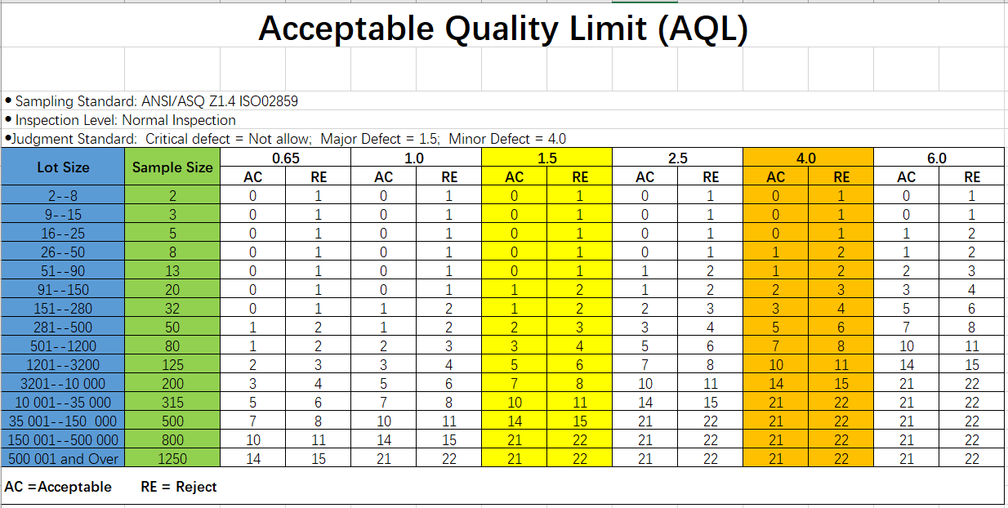

**Quality control regular Checklist:**

1. The packing and packaging.
2. The quantity produced (semi finished, finished and packed).
3. The product specifications (sizes, colors, materials).
4. The visual appearance and workmanship (cosmetic check).
5. All possible functions tests and safety tests.
6. The labeling and marking.
7. Other checking points requested by clients.

Please try to describe your products and quality control requirements in details, like craftmanship, material, color, function, package, critical checking points ect. Please also attach a picture of your product here if possible.